**Candy house9** **Switzerland fruit sugar**

**200gNT$105**

**★Product Features**

soft delicious  
Integrated fruit flavors  
Sweet but not greasy

**★production state**  
**Germany**

**Jili integrated shellfish tropical jelly beans**

**99g NT$99**

**★Product Features**

Whether a meeting or a plane, former U.S.President Ronald Reagan always forget to always carry the "Reagan sugar," said the Jelly bean candy

**★production state**  
  
**USA**

**Peko** milk bags

**NT$69**

**★Product Features**

PEKO milk bags of sugar, is a flavor popular, to its inception in early 1950, a special taste popular in Japan five decades, toffee mouth of the entrance, as if it makes the mother to experience the traditional craft and sweet and warm.

**★production state**  
  
**Japan**

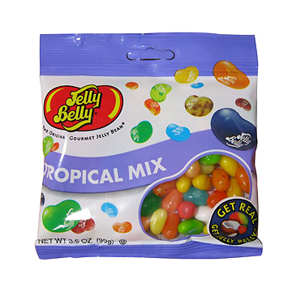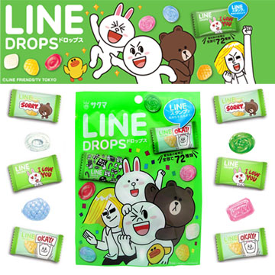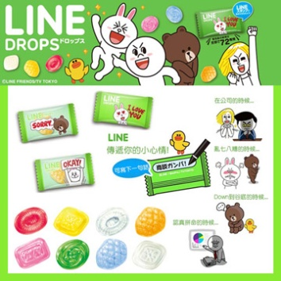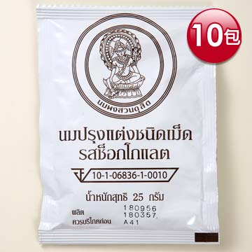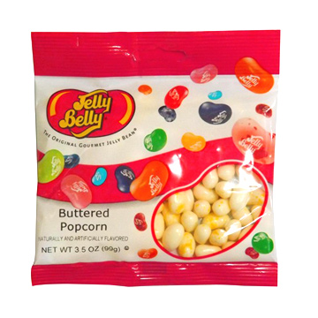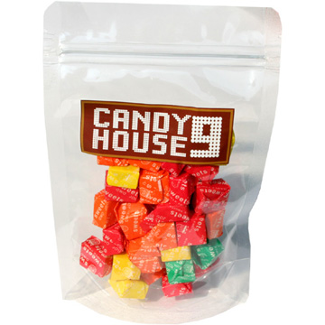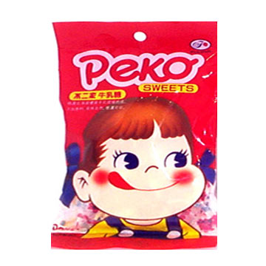

**Royal Thai milk tablets**

**NT280**

**★Product Features**

S & P to see the King Adulyadej children from poor families, as living in poverty can not afford the expensive milk, child malnutrition lack of calcium, so specifically at the Royal pasture produce milk tablets, so that thepeople can use cheap price to buy milk tablets some nutritional supplements that

**★production state**

**Thailand**

**LINEComprehensive fruit sugar**

**60g*2 NT 138**

**★production state**

**Japan**

**Jili Tony popcorn jelly beans**

**99g NT 89**

**★Product Features**

Whether a meeting or a plane, former U.S. President Ronald Reagan always forget to always carry the "Reagan sugar," said the Jelly bean candy

**★production state**  
**USA**

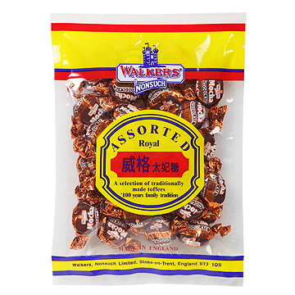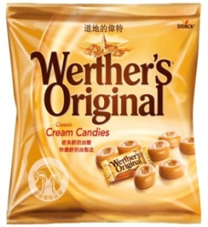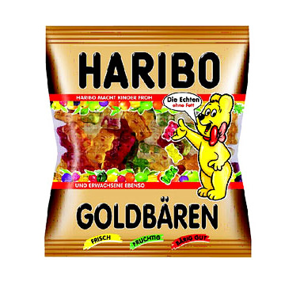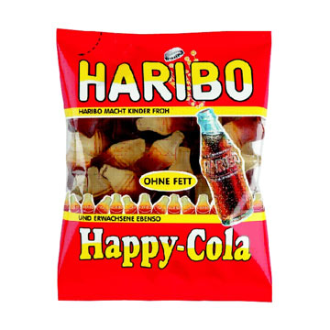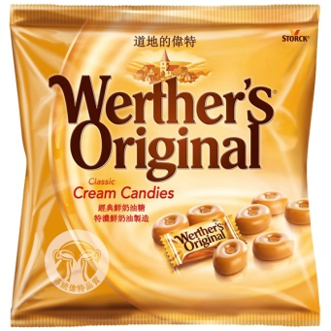

**British Whig toffee - Coffee**

**270g NT $99**

**★Product Features**British imports famous old brand The most unique manufacturing process of traditional recipe taste World-renowned best-selling brands A variety of integrated flavors

**★production state**  
**United Kingdom**

**HARIBO GOLDBAREN 200g**

**NT $99**

**★Product Features**  
Harry Bear for the world-renowned best-selling brands, a variety of shapes and flavors special formula of raw materials and manufacturing process, unique taste, there are a variety of fruit flavors enhanced modern portfolio lacking teeth chewing ability

**★production state**

**Germany**

**HARIBO Happy-cola**

**200g NT $99**

**★Product Features**  
Harry Bear for the world-renowned best-selling brands, a variety of shapes and flavorsSpecial formula of raw materials and manufacturing process, unique taste, lacking in modern dental enhance the ability to chew.  
Coke tastes

**★production state**

**Germany**

**道地偉特糖200g NT $89**

**★Product Features**

A long time ago, in a small town all called Waite has named Nobel candy shop, he used pure butter and fresh cream, sugar, brown sugar and a pinch of salt, baking simmered out with one of the best eating milk sugar because this cream sugar so delicious, so they put this sugar Waite named to commemorate his hometown.

**★production state**

**Germany**

**Student: Patty Vivian Iren lin Iren Zhang**

**The way to buy：PChome shopping Wed**

**Web address：http://shopping.pchome.com.tw/index/**

**HUST University of Science and Technology Department of IBM mice student**