176. Which of the following IP addresses fall into the CIDR block of 115.64.4.0/22? (Choose three.)

A. 115.64.8.32

B. 115.64.7.64

C. 115.64.6.255

D. 115.64.3.255

E. 115.64.5.128

F. 115.64.12.128

**Answer:** BCE

473. What can be done to secure the virtual terminal interfaces on a router? (Choose two.)

A. Administratively shut down the interface.

B. Physically secure the interface.

C. Create an access list and apply it to the virtual terminal interfaces with the access-group command.

D. Configure a virtual terminal password and login process.

E. Enter an access list and apply it to the virtual terminal interfaces using the access-class command.

**Answer:** DE

575. Refer to the exhibit. Which three variables (router, protocol port, and router ACL direction) apply to an extended ACL that will prevent student 01 from securely browsing the internet? (Choose three.)

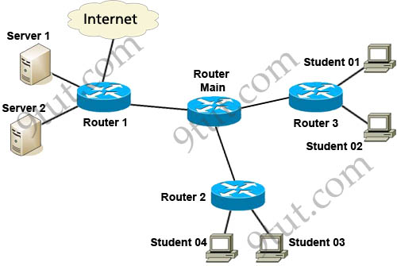

A. OUT

B. Router 3

C. HTTTP

D. IN

E. Router 1

**Answer:** BCD

595. Which two statements apply to dynamic access lists? (Choose two)

A. they offer simpler management in large internetworks.

B. you can control logging messages.

C. they allow packets to be filtered based on upper-layer session information.

D. you can set a time-based security policy.

E. they provide a level of security against spoofing.

F. they are used to authenticate individual users.

**Answer:** CD

634. The access control list shown in the graphic has been applied to the Ethernet interface of router R1 using the ip access-group 101 in command. Which of the following Telnet sessions will be blocked by this ACL? (Choose two)



A. from host PC1 to host 5.1.1.10

B. from host PC1 to host 5.1.3.10

C. from host PC2 to host 5.1.2.10

D. from host PC2 to host 5.1.3.8

**Answer:** BD

639. Refer to the graphic. It has been decided that PC1 should be denied access to Server. Which of the following commands are required to prevent only PC1 from accessing Server1 while allowing all other traffic to flow normally? (Choose two)

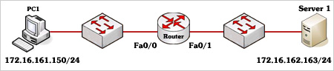

A. Router(config)# interface fa0/0

Router(config-if)# ip access-group 101 out

B. Router(config)# interface fa0/0

Router(config-if)# ip access-group 101 in

C. Router(config)# access-list 101 deny ip host 172.16.161.150 host 172.16.162.163

Router(config)# access-list 101 permit ip any any

D. Router(config)# access-list 101 deny ip 172.16.161.150 0.0.0.255 172.16.162.163 0.0.0.0

Router(config)# access-list 101 permit ip any any

**Answer:** BC

640. Your boss is learning a CCNA training course, refer to the exhibit. The access list has been configured on the S0/0 interface of router RTB in the outbound direction. Which two packets, if routed to the interface, will be denied? (Choose two)

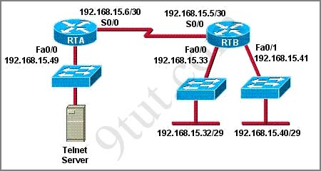

access-list 101 deny tcp 192.168.15.32 0.0.0.15 any eq telnet

access-list 101 permit ip any any

A. source ip address: 192.168.15.5; destination port: 21

B. source ip address: 192.168.15.37 destination port: 21

C. source ip address: 192.168.15.41 destination port: 21

D. source ip address: 192.168.15.36 destination port: 23

E. source ip address: 192.168.15.46; destination port: 23

F. source ip address: 192.168.15.49 destination port: 23

**Answer:** DE