46. For which type of connection should a straight-through cable be used?

A. switch to switch

B. switch to hub

C. switch to router

D. hub to hub

E. router to PC

**Answer:** C

143. Refer to the exhibit. What type of connection would be supported by the cable diagram shown?

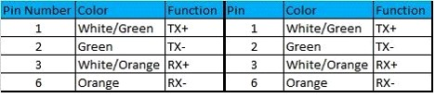

A. PC to router

B. PC to switch

C. server to router

D. router to router

**Answer:** B

144. Refer to the exhibit. What type of connection would be supported by the cable diagram shown?

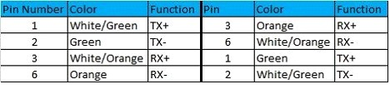

A. PC to router

B. PC to switch

C. server to switch

D. switch to router

**Answer:** A

254. Exhibit:



**Answer:**



266. Exhibit:



**Answer:**



397. Refer to the exhibit. Two buildings on the San Jose campus of a small company must be connected to use Ethernet with a bandwidth of at least 100 Mbps. The company is concerned about possible problems from voltage potential differences between the two buildings.

Which media type should be used for the connection?

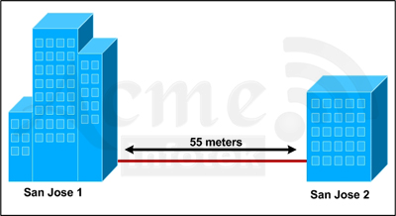

A. UTP cable

B. STP cable

C. coaxial cable

D. fiber optic cable

**Answer:** D

447.



**Answer:**



111. Which command would you configure globally on a Cisco router that would allow you to view directly connected Cisco devices?

A. enable cdp

B. cdp enable

C. cdp run

D. run cdp

**Answer:** C

92. Which statement describes the process of dynamically assigning IP addresses by the DHCP server?

A. Addresses are allocated after a negotiation between the server and the host to determine the length of the agreement.

B. Addresses are permanently assigned so that the hosts uses the same address at all times.

C. Addresses are assigned for a fixed period of time, at the end of the period, a new request for an address must be made.

D. Addresses are leased to hosts, which periodically contact the DHCP server to renew the lease.

**Answer:** D

138. Refer to the exhibit. Which rule does the DHCP server use when there is an IP address conflict?

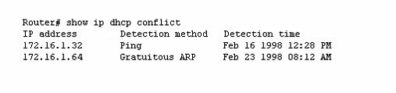

A. The address is removed from the pool until the conflict is resolved.

B. The address remains in the pool until the conflict is resolved.

C. Only the IP detected by Gratuitous ARP is removed from the pool.

D. Only the IP detected by Ping is removed from the pool.

E. The IP will be shown, even after the conflict is resolved.

**Answer:** A

315. Which statement is correct regarding the operation of DHCP?

A. A DHCP client uses a ping to detect address conflicts.

B. A DHCP server uses a gratuitous ARP to detect DHCP clients.

C. A DHCP client uses a gratuitous ARP to detect a DHCP server.

D. If an address conflict is detected, the address is removed from the pool and an administrator must resolve the conflict.

E. If an address conflict is detected, the address is removed from the pool for an amount of time configurable by the administrator.

F. If an address conflict is detected, the address is removed from the pool and will not be reused until the server is rebooted.

**Answer:** E

506. How does a DHCP server dynamically assign IP address to host?

A. Addresses are allocated after a negotiation between the server and the host to determine the length of the agreement.

B. Addresses are assigned for a fixed period of time. At the end of period, a newquest for an address must be made, and another address is then assigned.

C. Addresses are leased to host. A host will usually keep the same address by periodically contacting the DHCP sever to renew the lease.

D. Addresses are permanently assigned so that the host uses the same address at all times.

**Answer:** C

93. Which network protocol does DNS use?

A. FTP

B. TFTP

C. TCP

D. UDP

E. SCP

**Answer:** D

539. DNS servers provide what service?

A. they run a spell check on host names to ensure accurate routing

B. they map individual hosts to their specific IP address

C. they convert domain names into IP address

D. Given an IP address, they determine the name of the host that is sought

**Answer:** C