237. Refer to the exhibit. A junior network engineer has prepared the exhibited configuration file. What two statements are true of the planned configuration for interface fa0/1? (Choose two.)

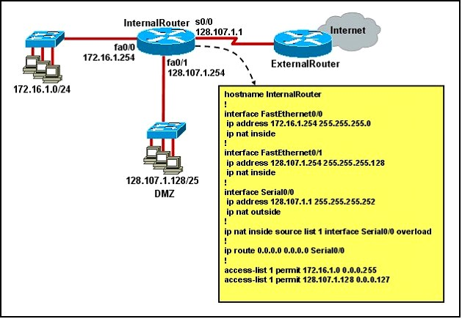



A. The two FastEthernet interfaces will require NAT configured on two outside serial interfaces.

B. Address translation on fa0/1 is not required for DMZ Devices to access the Internet.

C. The fa0/1 IP address overlaps with the space used by s0/0.

D. The fa0/1 IP address is invalid for the IP subnet on which it resides.

E. Internet hosts may not initiate connections to DMZ Devices through the configuration that is shown.

**Answer:** BE

511. What are two benefits of using NAT? (Choose two)

A. NAT protects network security because private networks are not advertised.

B. NAT accelerates the routing process because no modifications are made on the packets.

C. Dynamic NAT facilitates connections from the outside of the network.

D. NAT facilitates end-to-end communication when IPsec is enable.

E. NAT eliminates the need to re-address all host that require extemal access.

F. NAT conserves addresses through host MAC-level multiplexing.

**Answer:** AE

516. Which two statements about static NAT translations are true? (Choose two)

A. They are always present in the NAT table.

B. They allow connection to be initiated from the outside.

C. They can be configured with access lists, to allow two or more connections to be initiated from the outside.

D. They require no inside or outside interface markings because addresses are statically defined.

**Answer:** AB