129. Refer to the exhibit. Addresses within the range 10.10.10.0/24 are not being translated to the 1.1.128.0/16 range. Which command shows if 10.10.10.0/24 are allowed inside addresses?
A. debug ip nat
B. show access-list
C. show ip nat translation
D. show ip nat statistics
Answer: B

147. Refer to the exhibit. Which command would allow the translations to be created on the router?
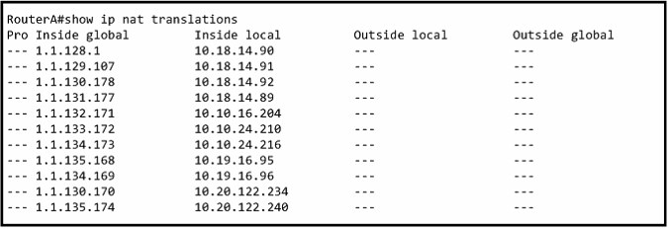
A. ip nat pool mynats 1.1.128.1 1.1.135.254 prefix-length 19
B. ip nat outside mynats 1.1.128.1 1.1.135.254 prefix-length 19
C. ip nat pool mynats 1.1.128.1 1.1.135.254 prefix-length 18
D. ip nat outside mynats 1.1.128.1 1.1.135.254 prefix-length 18
Answer: A

151. Refer to the exhibit. What does the (*) represent in the output?
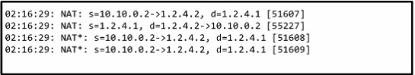
A. Packet is destined for a local interface to the router.
B. Packet was translated, but no response was received from the distant device.
C. Packet was not translated, because no additional ports are available.
D. Packet was translated and fast switched to the destination.
Answer: D

152. Refer to the exhibit. What command sequence will enable PAT from the inside to outside network?
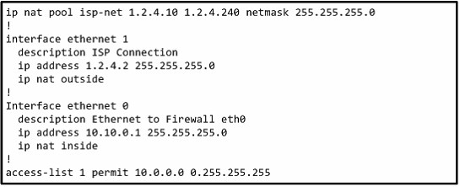
A. (config) ip nat pool isp-net 1.2.4.2 netmask 255.255.255.0 overload
B. (config-if) ip nat outside overload
C. (config) ip nat inside source list 1 interface ethernet1 overload
D. (config-if) ip nat inside overload
Answer: C

277. Drag Drop
Answer:
NAT addresses can be divided into two categories: inside network and outside network which are defined based on the NAT functions. The device that has NAT functions connects the inside and the outside network like a bridge, the NIC connected to the inside network is called "inside", the NIC connected to the outside network is called "outside", that is to say, the inside addresses are used by the inside network devices, while the outside addresses are used by the outside network devices.
Addresses can also be divided into local and global addresses. Local address refers to the address that can be seen and used by the inside network devices; while global address refers to the address that can be seen and used by the outside network devices.
These four addresses are :
Inside local address is the IP address used by the inside network devices, which is often a private address. Inside global address is a public address provided by ISP. It is often used when the inside network devices communicate with the outside network devices.
Outside local address is the address used by the outside network device as it appears to the inside
network device. It is not necessarily a public network address.
Outside global address is the real address used by the outside network devices.
IP packets sent from the inside network devices regard "inside local address" as the source address and
"outside local address" as the destination address. When the packets reach the "inside" interface of the
NAT equipment, the addresses will be translated into "inside global address" and "outside global
address", the packets will be out from the "outside" interface .
In the same way, IP packets sent from the outside network devices regard "outside global address" as the source address and "inside global address" as the destination address. When the packets reach the "outside" interface of the NAT equipment, the addresses will be translated into "outside local address" and "inside local address", the packets will be out from the "inside" interface.

280. Drop
The Missouri branch office router is connected through its s0 interface to the Alabama Headquarters router s1 interface. The Alabama router has two LANs. Missouri user obtain internet access through the Headquarters router. The network interfaces in the topology are addressed as follows:
Missouri: e0-192.168.35.33/28;
Alabama: e0-192.168.35.49/28
e1-192.168.35.65/28
s1-192.168.35.34/28
The accounting server has the address of 192.168.35.66/28.Match the access list conditions on the left with the goals on the right.(Not all options on the left are used.)
Answer:

295. Refer to the exhibit. What statement is true of the configuration for this network?
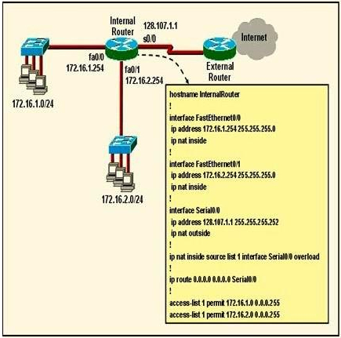
A. The configuration that is shown provides inadequate outside address space for translation of the number of inside addresses that are supported.
B. Because of the addressing on interface FastEthemet0/1, the Seria0/0 interface address will not support the NAT configuration as shown.
C. The number 1 referred to in the ip nat inside source command references access-list number1.
D. ExtemalRouter must be configured with static routers to networks 172.16.2.0/24.
Answer: C

404. Refer to the topology and router configuration shown in the graphic. A host on the LAN is accessing an FTP server across the Internet. Which of the following addresses could appear as a source address for the packets forwarded by the router to the destination server?
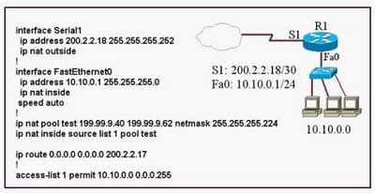
A. 10.10.0.1
B. 10.10.0.2
C. 199.99.9.33
D. 199.99.9.57
E. 200.2.2.17
F. 200.2.2.18
Answer: D

645. Refer to the exhibit,
How many interfaces on R1 should be configured as IP NAT inside to grant external access to the entire?
A. 1
B. 3
C. 4
D. 5
Answer: C

251. NAT-LAB
Answer:
Bomar(Config)#access-list 1 permit 192.168.16.33 0.0.0.15
Bomar(Config)#access-list 1 deny any
Bomar(Config)#ip nat pool Test 198.18.237.225 198.18.237.230 prefix-length 29
Bomar(Config)#ip nat inside source list 1 pool Test overload
Bomar(Config)#interface fa0/0
BomarConfig-if)#ip nat inside
Bomar(Config)#interface S0/0
Bomar(Config-if)#ip nat outside
Bomar(Config-if)#exit
Bomar#Copy run start
Question:
A network associate is configuring a router for the weaver company to provide internet access. The ISP has provided the company six public IP addresses of 198.18.184.105 198.18.184.110. The company has 14 hosts that need to access the internet simultaneously. The hosts in the company LAN have been assigned private space addresses in the range of 192.168.100.17 - 192.168.100.30 .
Click on image to view:
Answer:
Bomar(Config)#access-list 1 permit 192.168.100.17 0.0.0.15
Bomar(Config)#access-list 1 deny any
Bomar(Config)#ip nat pool Test 198.18.237.225 198.18.237.230 prefix-length 29
Bomar(Config)#ip nat inside source list 1 pool Test overload
Bomar(Config)#interface fa0/0
BomarConfig-if)#ip nat inside
Bomar(Config)#interface S0/0
Bomar(Config-if)#ip nat outside
Bomar(Config-if)#exit
Bomar#Copy run start
Need to special note : the inside IP address do not according to the the addree in picture , you must
follow the given address configuration, please do not learn by rote但要特別說明的是這個裡面的IP地址和圖中的地址是不對的你一定要按照考題給定的地址做配置不能硬背

273. LAB
You work as a network technician at Test.com. Study the exhibit carefully. You are required to perform configurations to enable internet access. The Test ISP has given you six public IP addresses in the 198.18.32.65 198.18.32.70/29 range. Test.com has 62 clients that needs to have simultaneous internet access. These local hosts use private IP addresses in the 192.168.6.65 - 192.168.6.126/26 range. You need to configure Router Test1 using the TestA console. You have already made basic router configuration.
You have also configured the appropriate NAT interfaces; NAT inside and NAT outside respectively. Now you are required to finish the configuration of Test1.
Answer:
Test1: Test1#Config t
Test1(Config)#interface fa0/0
Test1(Config-if)#ip nat inside
Test1(Config)#interface S0/0
Test1(Config-if)#ip nat outside
Test1(Config-if)#exit
Test1(Config)#access-list 1 permit 192.168.6.65 0.0.0.63
Test1(Config)#access-list 1 deny any
Test1(Config)#ip nat pool nat_test 198.18.32.65 198.18.32.70 prefix-length 29
Test1(Config)#ip nat inside source list 1 pool nat_test overload
This question tests the knowledge of NAT. The IP addresses in this question are changeable.

