16. Which two topologies are using the correct type of twisted-pair cables? (Choose two.)
A.
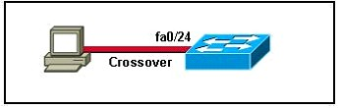
B.
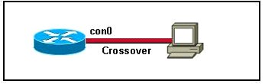
C.
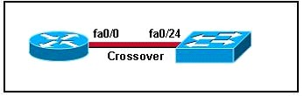
D.
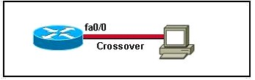
E.
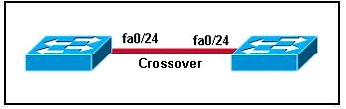
Answer: DE

134. Which two Ethernet fiber-optic modes support distances of greater than 550 meters? (Choose two.)
A. 1000BASE-CX
B. 100BASE-FX
C. 1000BASE-LX
D. 1000BASE-SX
E. 1000BASE-ZX
Answer: CE

8. What are two reasons a network administrator would use CDP? (Choose two.)
A. to verify the type of cable interconnecting two devices
B. to determine the status of network services on a remote device
C. to obtain VLAN information from directly connected switches
D. to verify Layer 2 connectivity between two devices when Layer 3 fails
E. to obtain the IP address of a connected device in order to telnet to the device
F. to determine the status of the routing protocols between directly connected routers
Answer: DE

372. Refer to the exhibit. The two exhibit devices are the only Cisco devices on the network. The serial network between the two devices has a mask of 255.255.255.252. Given the output that is shown, what three statements are true of these devices? (Choose three.)
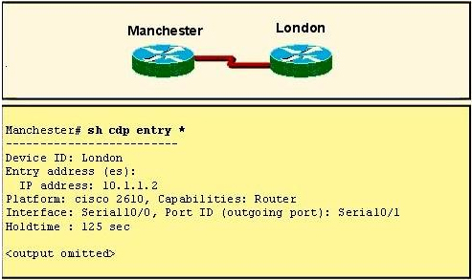
A. The Manchester serial address is 10.1.1.1.
B. The Manchester serial address is 10.1.1.2.
C. The London router is a Cisco 2610.
D. The Manchester router is a Cisco 2610.
E. The CDP information was received on port Serial0/0 of the Manchester router.
F. The CDP information was sent by port Serial0/0 of the London router.
Answer: ACF

596. Refer to the exhibit. Which two statements are true of the interfaces on switch1? (Choose two)
A. A hub is connected directly to FastEthernet0/5
B. FastEthernet0/1 is configured as a trunk link.
C. FastEthernet0/5 has statically assigned mac address
D. Interface FastEthernet0/2 has been disable.
E. Multiple devices are connected directly to FastEthernet0/1.
F. FastEthernet0/1 is connected to a host with multiple network interface cards.
Answer: AB

76. Which two tasks does the Dynamic Host Configuration Protocol perform? (Choose two.)
A. Set the IP gateway to be used by the network.
B. Perform host discovery used DHCPDISCOVER message.
C. Configure IP address parameters from DHCP server to a host.
D. Provide an easy management of layer 3 devices.
E. Monitor IP performance using the DHCP server.
F. Assign and renew IP address from the default pool.
Answer: CF

91. When a DHCP server is configured, which two IP addresses should never be assignable to hosts?
(Choose two.)
A. network or subnetwork IP address
B. broadcast address on the network
C. IP address leased to the LAN
D. IP address used by the interfaces
E. manually assigned address to the clients
F. designated IP address to the DHCP server
Answer: AB

424. What TCP/IP stack configuration features can DHCP provide, in addition to assigning an IP address? (Choose three.)
A. Default gateway
B. DNS servers
C. FTP server
D. Helper address
E. Subnet mask
F. TFTP server
Answer: A, B, E

